# **MongoDB Task**

**Design database for Zen class programme:**

users

codekata

attendance

topics

tasks

company_drives

mentors

Zen_class Database:

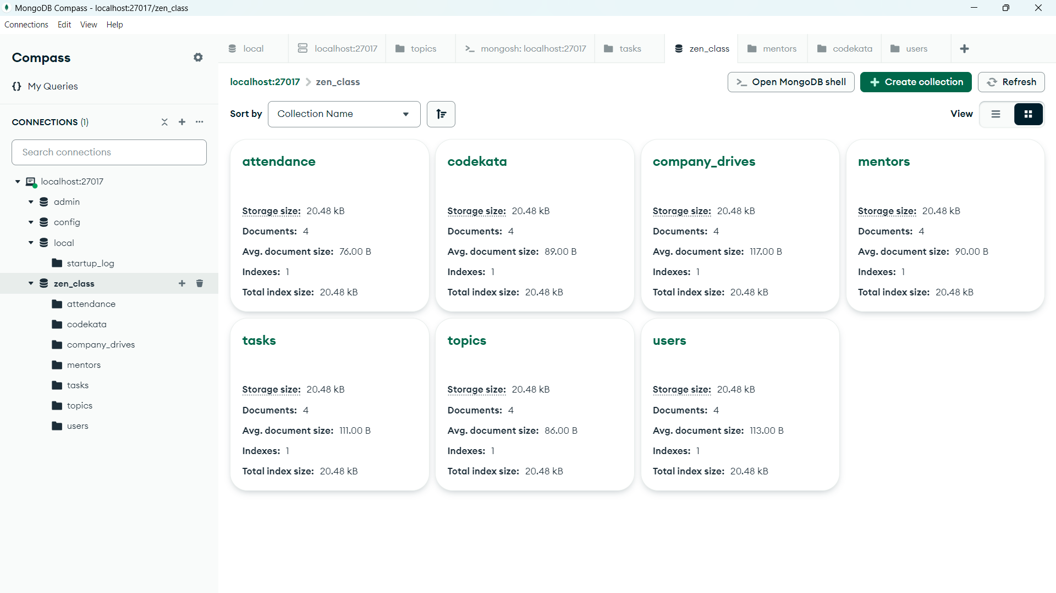

Queries:

1. Find all the topics and tasks which are thought in the month of October

db.topics.aggregate([

{

$match: {

date: {

$gte"2020-10-01",

$lte: "2020-10-31"

}

}

},

{

$lookup: {

from: "tasks",

localField: "task_id",

foreignField: "_id",

as: "related_tasks"

}

},

{

$project: {

_id:0,

topic_name: 1,

date: 1,

related_tasks: "$related_tasks.task_name"

}

}

]);

1. Find all the company drives which appeared between 15 oct-2020 and 31-oct-2020

db.company_drives.find({

date: {

$gte: "2020-10-15"

$lte: "2020-10-31"

}

});

1. Find all the company drives and students who are appeared for the placement.

db.company_drives.aggregate([

{

$lookup: {

from: "users",

localField: "user_ids",

foreignField: "_id",

as: "appeared_students"

}

},

{

$project: {

drive_name: 1,

appeared_students: "$appeared_students.name"

}

}

]);

1. Find the number of problems solved by the user in codekata

db.codekata.aggregate([

{

$group: {

_id: "$user_id",

total_problems_solved: { $sum: "$problems_solved" }

}

},

{

$lookup: {

from: "users",

localField: "_id",

foreignField: "_id",

as: "user_info"

}

},

{

$unwind: "$user_info"

},

{

$project: {

_id:0,

"user_name": "$user_info.name",

total_problems_solved: 1,

}

}

]);

1. Find all the mentors with who has the mentee's count more than 15

db.mentors.find({

mentee_count:{$gt:15}});

1. Find the number of users who are absent and task is not submitted  between 15 oct-2020 and 31-oct-2020

db.attendance.aggregate([

{

$match: {

date: { $gte: "2020-10-15", $lte: "2020-10-31" },

status: "absent"

}

},

{

$lookup: {

from: "tasks",

localField: "user_id",

foreignField: "user_id",

as: "user_tasks"

}

},

{

$unwind: "$user_tasks"

},

{

$match: {

"user_tasks.submission_status": "not submitted"

}

},

{

$group: {

_id: null,

count: { $sum: 1 }

}

}

]);